**Lab 17**

**Name :-** Aryan Dilipbhai Langhanoja

**Date :-** 26-09-2023

**Enrollment No :-** 92200133030

**CO1: To write, test, and debug simple Python programs**

**CO2: To implement Python programs with conditional, loops and functions**

**Task 1:- Creating a Series by passing a list of values, letting pandas create a default RangeIndex.**

**Python Code:**

import numpy as np

import pandas as pd

s = pd.Series([1, 3, 5, np.nan, 6, 8])

print(s)

**Output:**

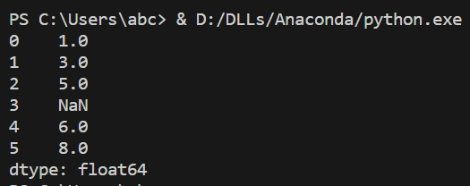

**Task 2:- Creating a DataFrame by passing a NumPy array with a datetime index using date_range() and labeled columns**

**Python Code:**

import numpy as np

import pandas as pd

dates = pd.date_range("20130101", periods=6)

df = pd.DataFrame(np.random.randn(6, 4), index=dates, columns=list("ABCD"))

print(df)

**Output:**

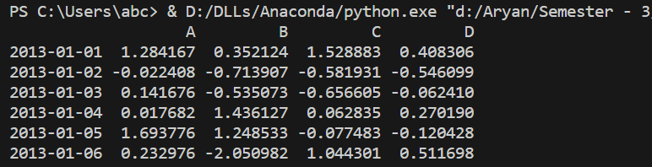

**Task 3:- Creating a DataFrame by passing a dictionary of objects where the keys are the column labels and the values are the column values.**

**Python Code:**

import numpy as np

import pandas as pd

df2 = pd.DataFrame(

{

"A": 1.0,

"B": pd.Timestamp("20130102"),

"C": pd.Series(1, index=list(range(4)), dtype="float32"),

"D": np.array([3] * 4, dtype="int32"),

"E": pd.Categorical(["test", "train", "test", "train"]),

"F": "foo",

}

)

print(df2)

**Output:**

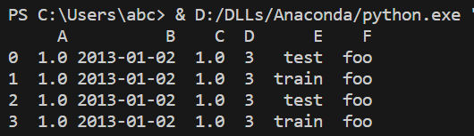

**Task 4:- Checking The DataTypes of Each Column In Dataframe**

**Python Code:**

import numpy as np

import pandas as pd

df2 = pd.DataFrame(

{

"A": 1.0,

"B": pd.Timestamp("20130102"),

"C": pd.Series(1, index=list(range(4)), dtype="float32"),

"D": np.array([3] * 4, dtype="int32"),

"E": pd.Categorical(["test", "train", "test", "train"]),

"F": "foo",

}

)

print(df2.dtypes)

**Output:**

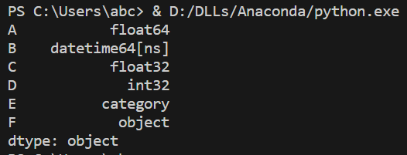

**Task 5:- Implement head Function**

**Python Code:**

import numpy as np

import pandas as pd

df2 = pd.DataFrame(

{

"A": 1.0,

"B": pd.Timestamp("20130102"),

"C": pd.Series(1, index=list(range(4)), dtype="float32"),

"D": np.array([3] * 4, dtype="int32"),

"E": pd.Categorical(["test", "train", "test", "train"]),

"F": "foo",

}

)

print(df2.head())

**Output:**

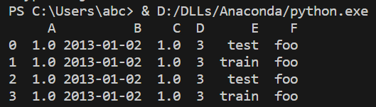

**Task 6:- Implement tail Function**

**Python Code:**

import numpy as np

import pandas as pd

df2 = pd.DataFrame(

{

"A": 1.0,

"B": pd.Timestamp("20130102"),

"C": pd.Series(1, index=list(range(4)), dtype="float32"),

"D": np.array([3] * 4, dtype="int32"),

"E": pd.Categorical(["test", "train", "test", "train"]),

"F": "foo",

}

)

print(df2.tail(3))

**Output:**

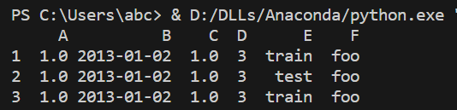

**Task 7:- Implement index Function**

**Python Code:**

import numpy as np

import pandas as pd

df2 = pd.DataFrame(

{

"A": 1.0,

"B": pd.Timestamp("20130102"),

"C": pd.Series(1, index=list(range(4)), dtype="float32"),

"D": np.array([3] * 4, dtype="int32"),

"E": pd.Categorical(["test", "train", "test", "train"]),

"F": "foo",

}

)

print(df2.index)

**Output:**



**Task 8:- Implement columns Function**

**Python Code:**

import numpy as np

import pandas as pd

df2 = pd.DataFrame(

{

"A": 1.0,

"B": pd.Timestamp("20130102"),

"C": pd.Series(1, index=list(range(4)), dtype="float32"),

"D": np.array([3] * 4, dtype="int32"),

"E": pd.Categorical(["test", "train", "test", "train"]),

"F": "foo",

}

)

print(df2.columns)

**Output:**



**Post Lab**

**Task 1:- Converting Dataframe into Numpy Array**

**Python Code:**

import numpy as np

import pandas as pd

df2 = pd.DataFrame(

{

"A": 1.0,

"B": pd.Timestamp("20130102"),

"C": pd.Series(1, index=list(range(4)), dtype="float32"),

"D": np.array([3] * 4, dtype="int32"),

"E": pd.Categorical(["test", "train", "test", "train"]),

"F": "foo",

}

)

print(df2.to_numpy())

**Output:**

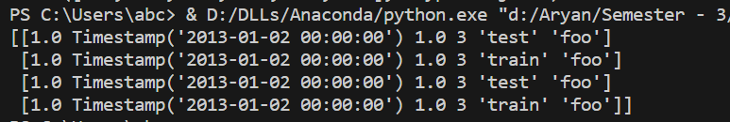

**Task 2:- Implemnting describe() Function**

**Python Code:**

import numpy as np

import pandas as pd

df = pd.DataFrame(

{

"A": 1.0,

"B": pd.Timestamp("20130102"),

"C": pd.Series(1, index=list(range(4)), dtype="float32"),

"D": np.array([3] * 4, dtype="int32"),

"E": pd.Categorical(["test", "train", "test", "train"]),

"F": "foo",

}

)

print(df.describe())

**Output:**

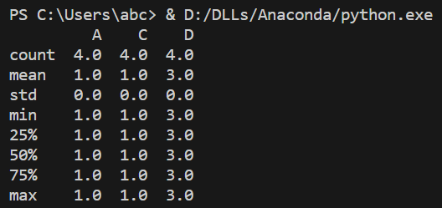

**Task 3:- Transposing your data**

**Python Code:**

import numpy as np

import pandas as pd

df = pd.DataFrame(

{

"A": 1.0,

"B": pd.Timestamp("20130102"),

"C": pd.Series(1, index=list(range(4)), dtype="float32"),

"D": np.array([3] * 4, dtype="int32"),

"E": pd.Categorical(["test", "train", "test", "train"]),

"F": "foo",

}

)

print(df.T)

**Output:**

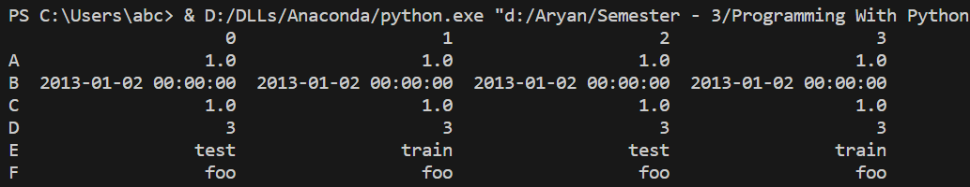

**Task 4:- Sorting your data (using** [**DataFrame.sort_index()**](https://pandas.pydata.org/docs/reference/api/pandas.DataFrame.sort_index.html#pandas.DataFrame.sort_index) **&** [**DataFrame.sort_values()**](https://pandas.pydata.org/docs/reference/api/pandas.DataFrame.sort_values.html#pandas.DataFrame.sort_values)**)**

**Python Code:**

import numpy as np

import pandas as pd

df = pd.DataFrame(

{

"A": 1.0,

"B": pd.Timestamp("20130102"),

"C": pd.Series(1, index=list(range(4)), dtype="float32"),

"D": np.array([3] * 4, dtype="int32"),

"E": pd.Categorical(["test", "train", "test", "train"]),

"F": "foo",

}

)

print(df.sort_index(axis=1, ascending=False))

print(df.sort_values(by="B"))

**Output:**

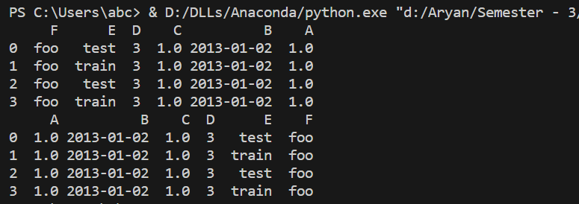

**Task 5:- Selection (getitem[],slice:,label, position)**

**Python Code:**

import numpy as np

import pandas as pd

df = pd.DataFrame(

{

"A": 1.0,

"B": pd.Timestamp("20130102"),

"C": pd.Series(1, index=list(range(4)), dtype="float32"),

"D": np.array([3] * 4, dtype="int32"),

"E": pd.Categorical(["test", "train", "test", "train"]),

"F": "foo",

}

)

print(df.loc["20130102":"20130104", ["A", "B"]])

print(df.iloc[3])

print(df[df["A"] > 0])

**Output:**

